** Archangel Michael Just a word**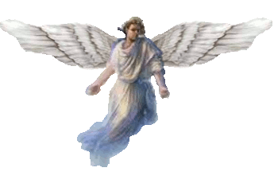

**There are many more Angels than people. We are Watchers, we don't interfere. There are a great many of us all over the Earth.**

**The wings of the small ones are much larger than depicted. We exist in many realms at the same time.** 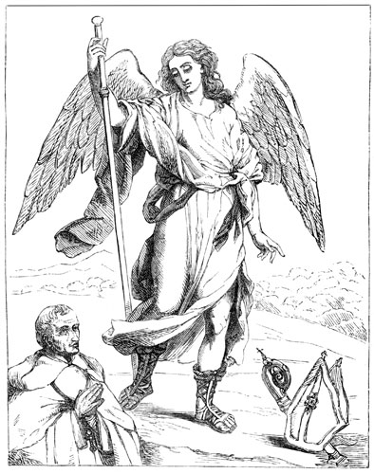

**The humans are only one of many species here on this planet. Many are bad and attack the people here.**

**This world is destine for death. It is the only way to destroy the evil here.**

**The Angels will just leave when this world ends. If the humans can't leave then 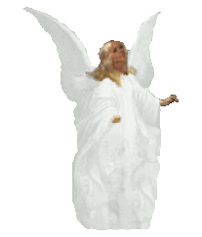they also will die.** 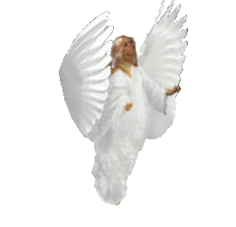

**We can't transport their bodies, there is simply no way. Star Gates or Time Travel can only transport spirits not the bodies of this dimension.**